


A warm welcome to employment with the Lead Employer Trust (LET)
hosted by Northumbria Healthcare NHS Foundation Trust

As a Doctor or Dentist in Training within NHS England Education North East (formally HEENE) the Lead Employer Trust (LET) employs you. You will receive one contract of employment, and it will remain unchanged as you rotate throughout placements within our region to fulfil your training programme. Please click the following link to visit our website, where you can discover all the necessary details for working with the LET, including policies, forms, payroll, occupational health, joining the LET bank, and contacts.

http://www.nenc-leademployertrust.nhs.uk/

What you need to know about being employed by the LET
About | Lead Employer Trust (nenc-leademployertrust.nhs.uk)

Electronic Staff Record (ESR) Self Service:
Please find below your username & password:
- Your username
- Your password

It is recommended that you use Internet Explorer or EDGE as an internet browser. The link you need is https://my.esr.nhs.uk/
When changing passwords, the password criteria are as follows:

How to reset password

- Passwords must have twelve characters or more.
- Passwords should differ from the four that came before them.
- Passwords cannot have certain words or phrases. It is advisable for users to refrain from using terms related to the system, their roles, or their location.
- To create a secure password, the National Cyber Security Centre (NCSC) recommends selecting three random words.
You now have an applicant profile on the LET ESR system which you can access and complete your Statutory and Mandatory e-learning prior to commencement.

Statutory and Mandatory Training:
Please view the LET e-learning policy gives details of all modules you must complete with renewal periods. Please view your account through the above ESR Self Service access to ensure you are compliant prior to your start date and every rotation of placement you do. You will receive reminders through ESR and from the LET when your e-learning is due to expire. Please note, you do not have to duplicate this e-learning with your host organization or prior to your renewal date. If you are asked to do so, please contact the LET.

Once your pre-employment checks are completed and you have been hired on the system, your ESR profile will change to an employee's.

Within your LET Employee ESR account this you can:
- View and complete any outstanding e-learning.
- Amend your personal details including your Next of Kin contacts.
- Amend your bank details.
- Amend your ED&I information.
- Access and view your monthly pay slip (you will not receive a hard copy)
- Access and view your annual P60 (you will not receive a hard copy)
- View your absence history.

Please visit here for further information and instructions on accessing your account and amending your details.

National Insurance Number:
It is essential that all prospective employees of the Trust have a National Insurance number. If you do not have an NI number, it is essential that you apply for this as soon as possible. Please visit https://www.gov.uk/apply-national-insurance-number to help you with your application.

Pension Information:
Please click here to access your guide to the NHS Pension Scheme. If you would like to transfer pension benefits from another scheme, please click here for further information. If you have an Added Years contract in place, please advise your Payroll Officer at once to ensure deductions can begin.

Salary and Payment details:
You will receive your monthly salary from the LET on the 28th of each month (please note this may differ in December & January). Where the 28th is not a working day (weekend or public holiday), you will be paid on the latest working day.

Wagestream
The LET offers Wagestream, which is a financial app to allow you as a LET employee to access financial support including:
Streaming – use flexible pay to access up to 15% of your basic salary prior to pay day.
Build Pot – put money aside for your future straight from your wages with a competitive interest rate.
Benefits Checker – understand if you are entitled to government support.
Everyday Savings – discounts and savings available to you.
Learning & Resources – articles to increase your financial confidence.
To use the app and register for Wagestream please visit https://wagestream.com/en/app-download

Travel Claims and Study Leave Expenses:
You will need to register on the EASY system, please see below:
The LET runs an electronic system to let you submit your claims and be paid promptly for these expenses. Please use the following link to access the system https://let.easy.giltbyte.com Select ‘Register Here’ when using the system for the first time. Prior to making a travel claim please ensure you have completed the ‘Agreed nominated Base form’ which can be found here You will need to complete the 'nominated base' form and return it to england.letexpenses.ne@nhs.net Please note, once you agree a nominated base and claimed expenses you are unable to change your nominated base.

You must also register your vehicle and upload a copy of your driving license and your business use insurance documents prior to making your first claim. For further information relating to this, please find Travel Expense Policy . You must include business insurance coverage with your travel claim; it will not be approved until all supporting documentation has been uploaded. Please make sure that the EASY system receives travel claims every month. Our trust travel policy states that all claims must be sent within the rotational appointment, and that reimbursement cannot be granted in retrospect for a period that exceeds three months. For any further information, contact the expenses team via e-mail england.letexpenses.ne@nhs.net
You may find the LET Payroll Useful Guides helpful.

Junior Doctor Forum and Exception Reporting:
Within your host Trust you will report all exceptions to the Guardian of Safe Working (GOSW). You will receive information on exception reporting systems at your host Trust induction. Your host Trust will also have a Junior Doctor forum which we encourage you to attend where possible.

If you are a GP (General Practice) Trainee based in Practice, a Public Health trainee or a Palliative Medicine trainee not working within an NHS Trust you report exceptions to LET GOSW Dr Jane Weatherstone. You will have received a login for the Allocate System, which lets you raise exception reports to Dr Weatherstone.

The LET holds a Junior Doctor Forum for GP, Palliative Medicine and Public Health trainees every three months; details of this forum will be emailed.

Salary Sacrifice Schemes:
The LET offers two salary sacrifice schemes, including Home Electronics and Fleet Cars. Please visit https://www.homeelectronicsolutions.co.uk/ or https://www.nhsfleetsolutions.co.uk/ Your VPD number to apply for these schemes is 441.

Please note your payroll number will not be generated until all your employment checks have been cleared and HR hires you on our systems.

Regional Collaborative Locum Bank:
The LET manages a Locum Bank for Junior Doctors across the Northeast & North Cumbria. If you would like to work locum shifts within the region, please use the QR code below.
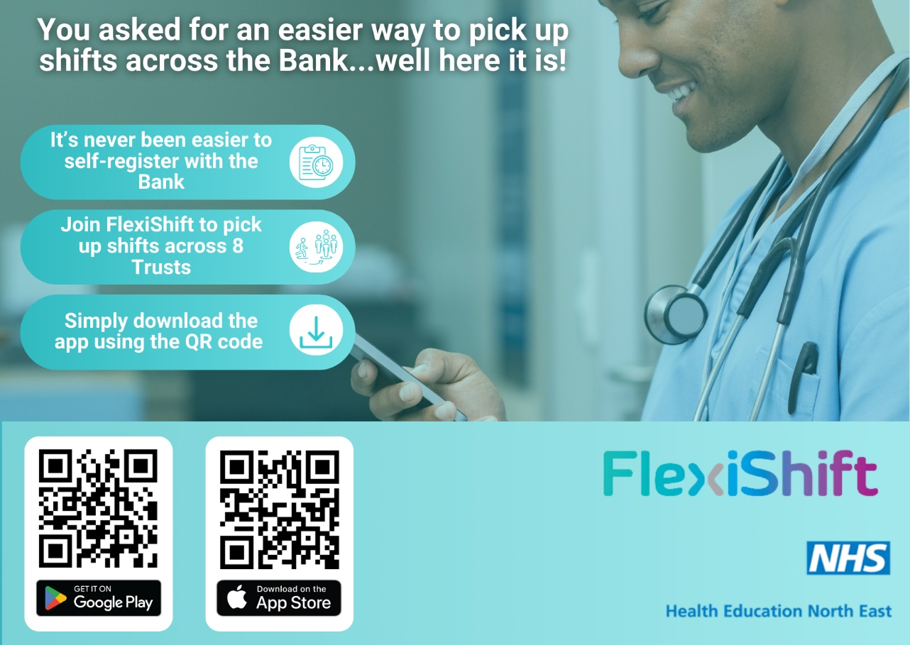

If you have any final questions which I have not addressed above, please email our helpdesk on
england.lethelpdesk.ne@nhs.net or telephone 0191 2754782.

Many thanks and we look forward to you working with us.

The LET team.

LET Contact Details

Payroll | let.payroll@nhct.nhs.uk  let.pensions@nhct.nhs.uk  LET.expenses@nhct.nhs.uk
OLM (Oracle Learning Management) – E-learning | england.letelearning@nhs.net
People Services  Foundation, Pediatrics', O&G | england.letfoundationog@nhs.net
People Services  General Practice, Academics | england.letgpacademic@nhs.net
People Services  Surgery, Anesthetics, Public Health, Psychiatry | england.letsurgeryfamily@nhs.net



